**Assignment 5 (Functional Composition)**

**Name - Chitra Paryani**

**NUID - 001869343**

Please find below screenshot of 13 implementations in Function.scala and 2 implementations in Movie.Scala and of all test cases passed in Assignment 5 (functional composition):

**Implemented map2 function:**

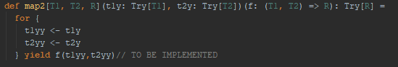

**Implemented map3 function:**

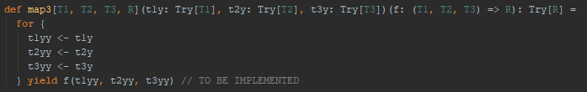

**Implemented map7 function:**

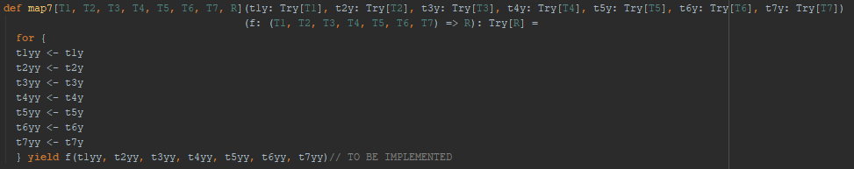

**Implemented lift function:**



**Implemented lift2 function:**



**Implemented lift3 function:**



**Implemented lift7 function:**

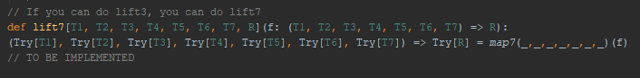

**Implemented invert2 function:**



**Implemented invert3 function:**

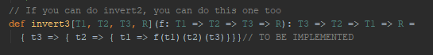

**Implemented invert4 function:**

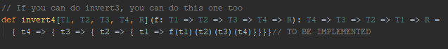

**Implemented uncurried2 function:**



**Implemented uncurried3 function:**

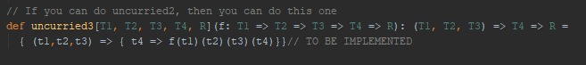

**Implemented uncurried7 function:**



**Screenshot of test cases passed in FunctionSpec.scala**

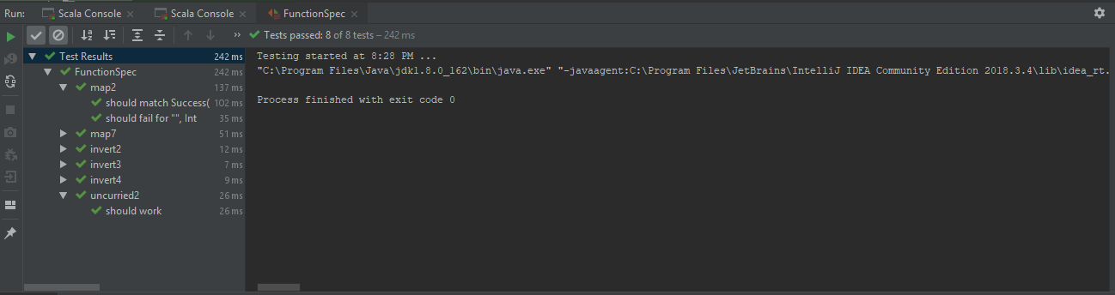

**Implemented MoviesProtocol object:**

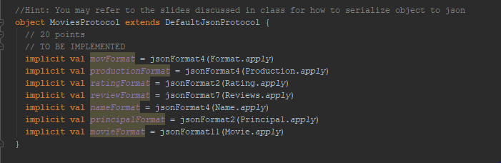

**Implemented testSerializationAndDeserialization function:**

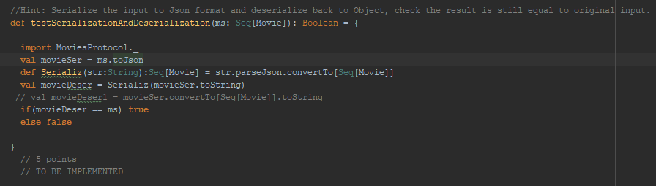

**Screenshot of test cases passed in MovieSpec.scala**

